**Tomcat Installation in Unix**

Log into the server using Putty & follow the below steps!

* **Downloading Tomcat as tar or zip file**
* Open the below link in browser & scroll down to Binary Distribution section

<https://tomcat.apache.org/download-80.cgi>

* Right Click on downloading link and select **copy link address**

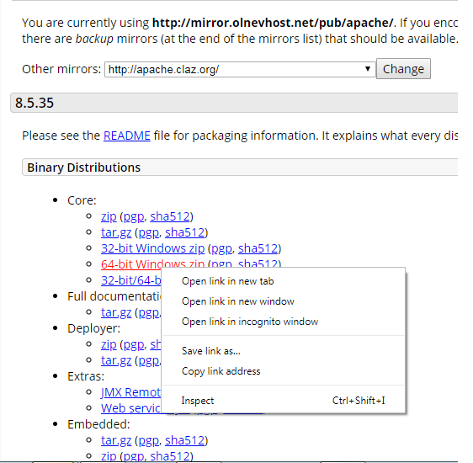

* Use wget commands to download from Putty Server

wget <copied link address>

**Example**: wget <http://mirror.olnevhost.net/pub/apache/tomcat/tomcat-8/v8.5.35/bin/apache-tomcat-8.5.35-windows-x64.zip>

* **Unzip the downloaded zip file**

unzip <downloaded tomcat file name with extension>

**Example**: unzip apache-tomcat-8.0.zip

* **Start the Server**

Move inside the bin folder of tomcat & execute the below command,

**./startup.sh**

To Stop the server, **./shutdown.sh**

* Once Server is started, Open the browser & hit the below link,

http://<**{{hostname}}**>:8080 [ replace hostname with your server’s host name]

By default, tomcat uses port 8080

**Facing Authorization issue while accessing Manager App ?**

In Higher versions of Tomcat, default username & password will not set. To set the username, password & user roles – follow the below steps!

* Open **tomcat-user.xml** from below path,

To move inside the folder,

cd {{Downloaded-tomcat-location}}/conf

To Open tomcat-user.xml,

vi tomcat-user.xml

Press “I” to activate Edit Mode & paste the below contents

<role rolename="manager-gui"/>

<role rolename="manager-script"/>

<role rolename="manager-jmx"/>

<role rolename="manager-status"/>

<user username="admin" password="admin" roles="manager-gui, manager-script, manager-jmx, manager-status"/>

Once done, press Esc button to exit Edit Mode & press :wq [colon w q] simultaneously to save file & exit from view mode!

* Add Manager.xml [new file] in the below path,

cd {{ Downloaded-tomcat-location }}/conf/Catalina/localhost

Create manager.xml using below command,

touch manager.xml [This will create manager.xml file]

Open manager.xml & paste the below contents,

vi manager.xml [This will Open manager.xml file]

Press “I” to activate Edit Mode & paste the below contents

<Context privileged="true" antiResourceLocking="false"

docBase="${catalina.home}/webapps/manager">

<!-- <Valve className="org.apache.catalina.valves.RemoteAddrValve" allow="^.*$" /> -->

</Context>

Once done, press Esc button to exit Edit Mode & press :wq [colon w q] simultaneously to save file & exit from view mode!

* Stop the server & restart it again!

cd {{ Downloaded-tomcat-location }}/bin

To Stop the server, ./shutdown.sh

To start the server, ./startup.sh

Now Open browser and hit the below link & access Manager Console

http://{{hostname}}:8080